**1. (a)**

→touch 23241072_1.txt 23241072_2.txt 23241072_3.txt 23241072_4.txt

→mkdir zawad1 zawad2

→mv /home/hypnosphynx/Desktop/assignment1/23241072_1.txt /home/hypnosphynx/Desktop/assignment1/zawad1/23241072_1.txt

→mv /home/hypnosphynx/Desktop/assignment1/23241072_2.txt /home/hypnosphynx/Desktop/assignment1/zawad1/23241072_2.txt

→mv /home/hypnosphynx/Desktop/assignment1/23241072_3.txt /home/hypnosphynx/Desktop/assignment1/zawad1/23241072_3.txt

→cp /home/hypnosphynx/Desktop/assignment1/zawad1/23241072_1.txt /home/hypnosphynx/Desktop/assignment1/zawad2/23241072_1.txt

→cp /home/hypnosphynx/Desktop/assignment1/zawad1/23241072_2.txt /home/hypnosphynx/Desktop/assignment1/zawad2/23241072_2.txt

→mkdir zawad3

→ cp -r /home/hypnosphynx/Desktop/assignment1/zawad1 /home/hypnosphynx/Desktop/assignment1/zawad3/zawad1

→cd zawad3

→ls -l

→chmod 755 zawad1

→ls-l

→ ../

→sudo mv /home/hypnosphynx/Desktop/assignment1/zawad3 /zawad3

→rm -r *

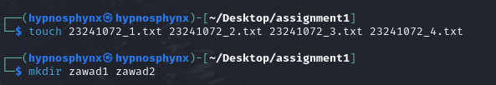

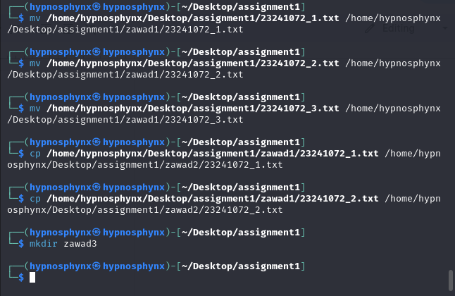

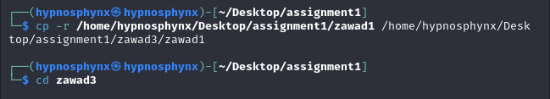

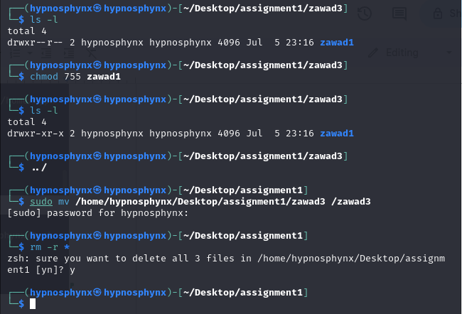



**(b)**

→ touch course.txt

→ gedit course.txt

→grep CSE course.txt | wc -l

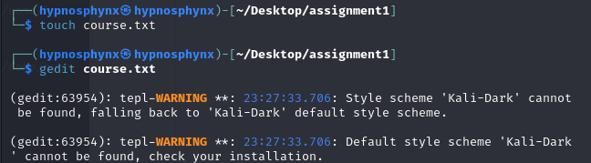



**(c)**

→ ls -a

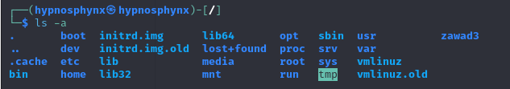

**(d)**

→ head -n 17 file.txt | tail -n 13

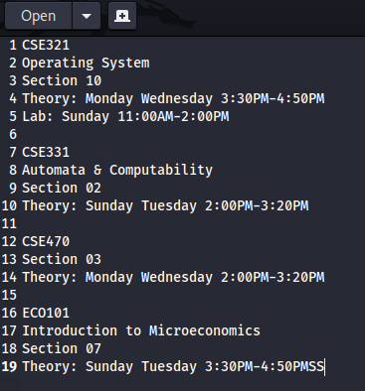

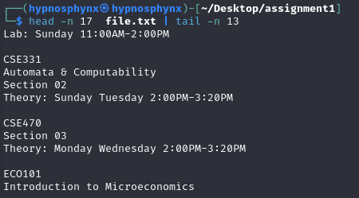

**2 Outputs**

**2 - a**

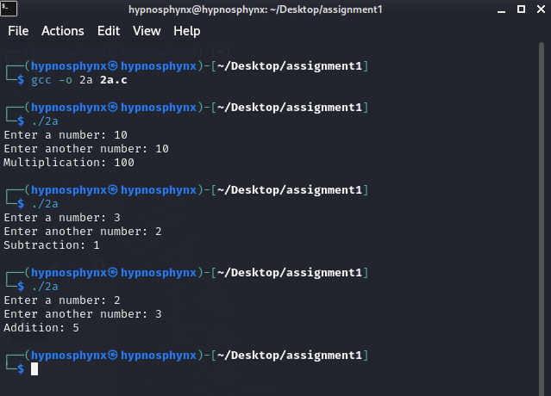

**2 - b**

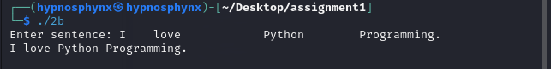

**2 - c**

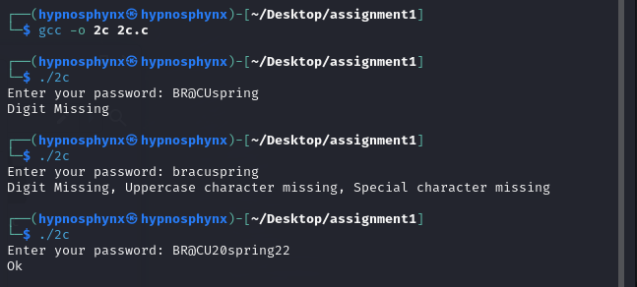

**2 - d**

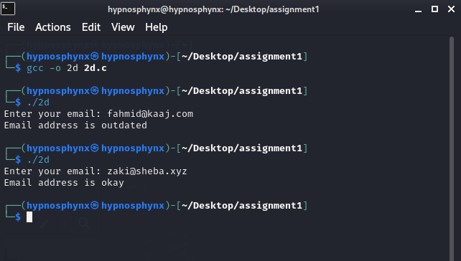

**2 - e**

